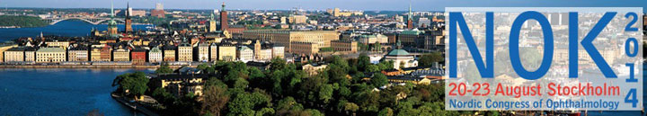

3rd Announcement
NOK 2014, Stockholm (Sweden), August 20-23, 2014

Dear Friends,

Newly added highlights on the Nordic Congress of Ophthalmology website!
The detailed scientific program for the congress is updated with the latest news.
We are pleased to announce the ACTA Honorary lecture will be presented by Professor Jan Ulrik Prause, Denmark, with the title: “Histopathological aspects of intra ocular melanocytic proliferation”.
Friday, August 22, at 11:00.
Confirmed Keynote Speakers:
Professor Jeffrey Nerad, USA: Oculoplastics and Orbit: History of ptosis surgery
Gerrit Melles, M.D. Ph.D., the Netherlands: Cornea and External Eye: DSAEK to DMEK to DMET? What if Fuchs endothelial dystrophy does not exist?
Professor Anja Tuulonen. Glaucoma: Sustainable glaucoma care
Professor, Anat Loewenstein, Israel, Medical Retina: Diabetic retinopathy: current treatment paradigm
The programme will also feature the very best of speakers from the five Nordic countries, alongside many renowned lecturers from all over the world.
A list of all the confirmed speakers is published on the NOK website: http://www.nok2014.com/Confirmed-Speakers.aspx
Registration
If you are not registered yet, it is still possible to register for the middle fee. The middle fee is available until June 18, so take the opportunity to register before this date!
Register here: https://www.akademikonferens.se/nok2014

Exhibition
A great number of companies within the fields of ophthalmology will exhibit the congress. The exhibit they put on display is state-of-the art and the most recent devices and technical developments will be featured.
The exhibition will be open throughout the congress. The exhibiting companies are listed on the website: http://www.nok2014.com/Exhibition-Sponsorship.aspx

For further information about the congress, please visit:
www.nok2014.com
Contact
If you have any questions, please contact the Conference secretariat:-
Academic Conferences - Tel. +46 18 67 15 27, +46 18 67 15 39, +46 18 67 10 03 - Fax. +46 18 67 35 30 - E-mail registration@nok2014.com

Academic Conferences
on behalf of

Stefan Seregard,
President NOK 2014

