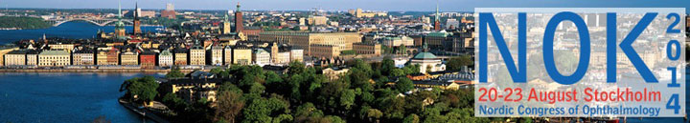

2nd Announcement
NOK 2014, Stockholm (Sweden), August 20-23, 2014

Dear fellow ophthalmologist,

A warm welcome to the Nordic Congress of Ophthalmology 2014 (NOK 2014)
Submit your abstract before March 5!
Welcome to submit your abstract to the NOK Congress. The last day for submission is March 5, 2014.
The abstract should be entered on-line by using the Abstract Submission Form
Please find more information and abstract guidelines on the website: Abstract Submission Information
Registration
To take advantage of the early bird fee, register before March 5.
Please find the registration link here: https://www.akademikonferens.se/nok2014

Programme
The scientific programme will feature the very best of speakers from the five Nordic countries, alongside many renowned lecturers from all over the world.
There will be more than 50 interesting parallel session, covering a range of topics from Allied Health to Vitreoretinal. Additionally confirmed are two sessions
arranged in collaboration with the SOE Young Ophthalmologists (YO), one of which in Cataract, and also two sessions arranged in collaboration with the AAO;
"New developments in Retina" and "Challenging Case Discussions".

Congress website with the updated programme at a glance:
www.nok2014.com
Contact
If you have any questions, please contact the Conference secretariat:-
Academic Conferences - Tel. +46 18 67 15 27, +46 18 67 15 39, +46 18 67 10 03 - Fax. +46 18 67 35 30 - E-mail registration@nok2014.com

Academic Conferences
on behalf of

Stefan Seregard,
President NOK 2014

